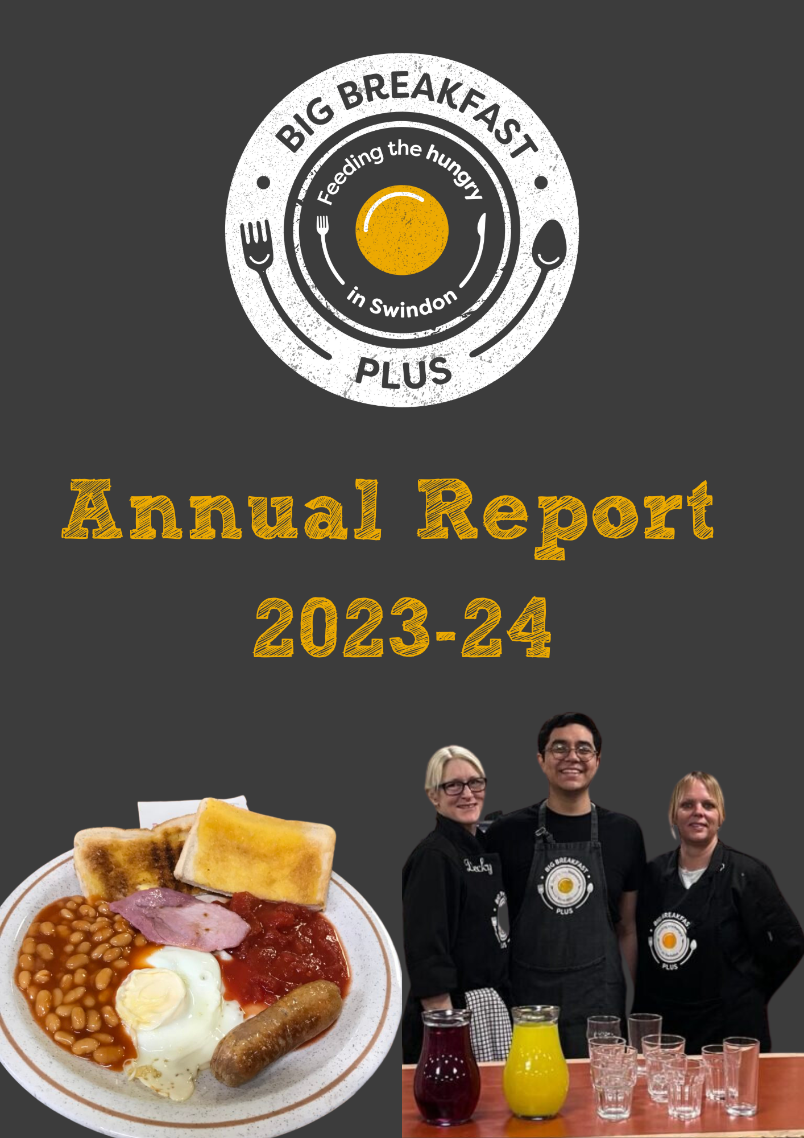

**Big Breakfast Plus**

**Charity number 1197825**

# **Introduction**

Big Breakfast Plus serves freshly cooked breakfasts for those in need in a warm and welcoming environment We are a volunteer led charity working with those who are homeless and those at risk of homelessness. Many of our guests are alone, or in temporary accommodation without cooking facilities and struggling to pay for wholesome food.

Not only do we serve freshly cooked breakfasts for those in need in our community café, we encourage our guests to meet, socialise and make friendships while enjoying a choice of breakfast. We continue facilitate an introduction to several support services including housing, welfare, health, advice, and addiction services. Many of our guests, after finding their feet, go on to become volunteers with Big Breakfast Plus.

We deliver our breakfast service at the Pilgrim Centre, Regents Circus, Swindon SN1 1PX seven mornings a week including bank holidays between 7.30am and 9am.

**Our Charitable Objects**

The relief of persons in Swindon and the surrounding area who are in conditions of need, hardship, and distress and of any persons who are homeless or at risk of becoming homeless, but not exclusively, by the provision of food and clothing.

**Our Approach**

To serve freshly cooked breakfasts, to those in need in Swindon in a warm and welcoming environment.

To identify and access funding opportunities to enable us provide food for up to 100 people each day.

**Our Values that drive us**:

|  |  |
| --- | --- |
| Non-Judgemental | Human Dignity |
| Acceptance | Hospitality |
| Simplicity | Agency |

**Our Service**

Demand has continued to grow throughout the year. In April 2023 we were serving 1042 - an average of 50 breakfasts a 5-day week to March 2024 when 2,550 breakfasts were served 7 days a week to an average of 85 people a day.

To give an idea of the volume of food we us through the year we cook 770 eggs (256 dozen a month) 770 rashers, 840 sausages, 55 tins of beans and 34 tins of tomatoes. We provide 50 litres of milk and 24 large boxes of cereal each week.

*Wayne, the Big Breakfast Plus Service Co-Ordinator commented: “Whilst we will always be here as a lifeline of many for our guests, we do hope to see the day when we are no longer needed as a service. Until then, we will continue to support those who need our help most.”*

# **Highlights**

#### **B&Q Distribution - Charity of the Year**

Along with four other local charities we enjoyed a year being supported by the people at B&Q. It was great fun, raising our profile at B&Q Family Day and we got to meet Peppa Pig. We were particularly pleased with their wonderful gifts of Christmas chocolates and Biscuits for everyone for our guests.

#### A group of people wearing clothing

#### **Celebrating the Kings Coronation May 2023**

As the nation gathered to celebrate the coronation of King Charles III, we were able to join in the festivities by hosting a breakfast indoor ‘street party’ This enabled the homeless and vulnerable community of Swindon to participate with the rest of the community marking this historic occasion. Many thanks to the team HR and marketing at TM Group who provided loads of balloons and bunting and helped to transform the Pilgrim Centre fit for the royal celebration.

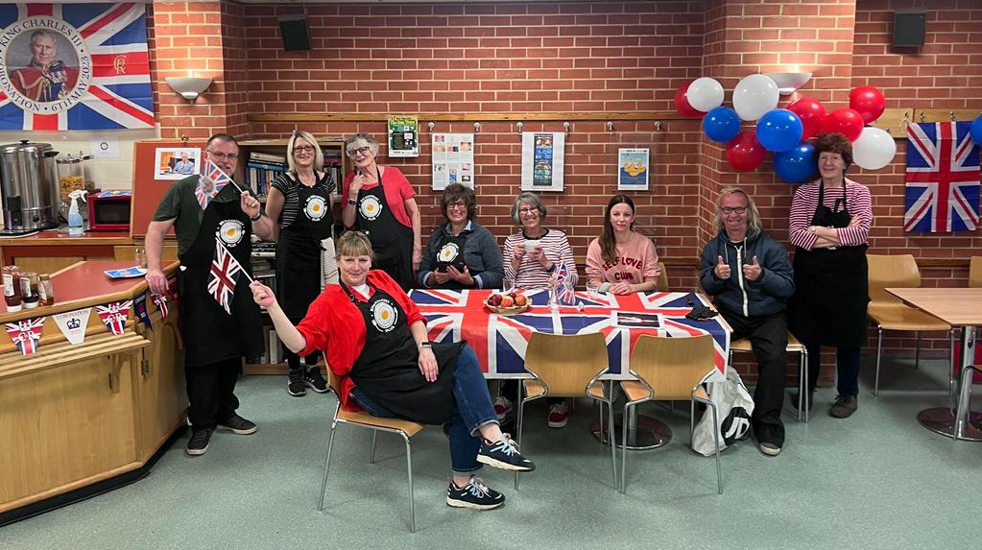

#### **Opening Seven Days a Week**

In November 2023 we went from five mornings a week to seven days service. Thanks to funding from the National Benevolent Charity, we were able to extend out breakfast service as a Winter Service and with the support of our volunteers it proved hugely successful. Many of our guests lead fairly chaotic lives, lacking routine so knowing the service was there every day provided them with a daily structure.

#### **Stars of BBC Points West**

Organised by Zurich Community Trust BBC Point West joined us in early November and spent a Breakfast shift filming and talking to our volunteers. They met some of our guests and learned their stories. The programme went out a few weeks later and as well Points West it was also featured on South and Oxfordshire raising our profile.

Zurich Community Trust made their own programme introduced by Steve Grimmett the CEO of the Trust alongside the BBC visit. They used the programme on all their social media and in their media coverage.

#### **Celebrating the Christmas holiday**

Thames Water Collections Team raised more than £500 running cake stall events and other activities inhouse. Some of the team then decorated the Pilgrim Centre for Christmas complete with a magnificent tree and lots of decorations.

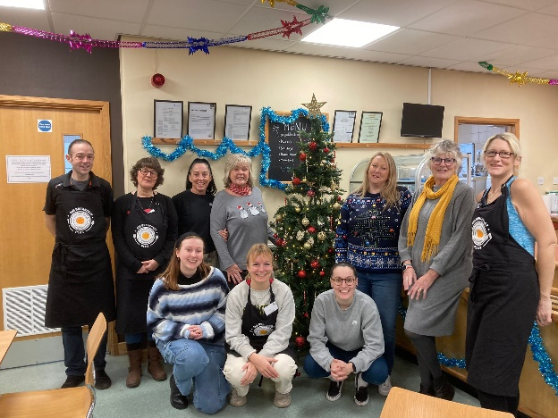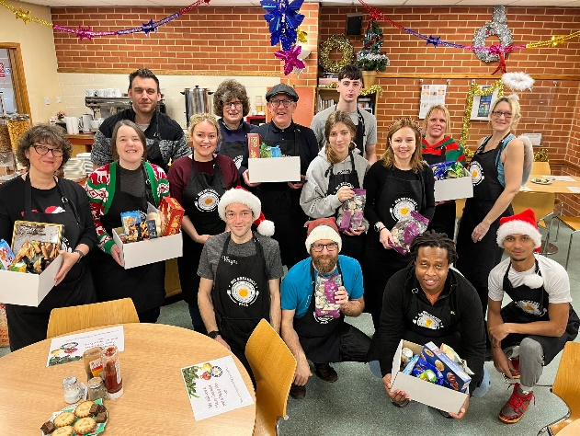

Thank you to B&Q Distribution employees for donating loads of boxes of luxury biscuits and to Zurich employees for their brilliant Christmas gifts for all our guests.

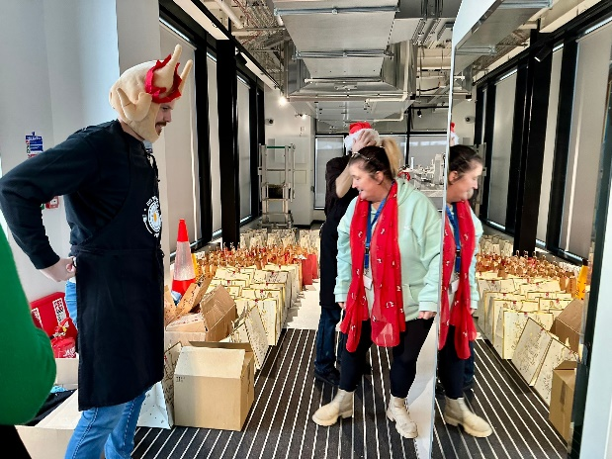

## **Funding**

Fund raising continues to be our number one priority in order to ensure we can feed the hungry in Swindon. We are delighted to be a charity partner of Zurich Community Trust. As well as a four-year funding plan we have benefited from advice, guidance, training opportunities and support around sustainability.

We are grateful to the National Benevolent Charity whose funding enabled us to reach more people in need including opening our doors from five mornings to seven mornings a week.

We are also grateful to Swindon Borough Council for their funding through the Government Household Support programme enabling us to reach more isolated people including those who are pensioners and those with disabilities.

As a part of our community, we were thankful for a number of generous sponsors including:

* Hilliers Funeral Service
* B & Q Distribution Centre Swindon
* The Rotary Club of Swindon Old Town
* Donations in memory of Margaret Simms
* North Wilts Model Engineering
* Asda Foundation and Asda Haydon Swindon (also food donations)
* Wanborough Farmers Market
* OneFamily.com
* Elevana Ltd
* Baxter Storey
* Bellinger Donnay Charitable Trust
* The FD Centre
* Emmanuel URC, Haydon Wick
* Thames Water Collections Team
* Steve’s Bargain Trips (food donations)
* Capita (food donations)

And thank you to the following people for their support in the last year:

* 10 Green Bottles (Berkley Farm) for donating and delivering 40 litres of organic milk every week.
* Helen Browning Organic for regular donations of organic Speedy Sausages
* Richard Bellemy, Business, and management consultant for advice and support to the trustees.
* Maurice Spillane for nominating Big Breakfast Plus for a Kings Award for Voluntary Service
* Janice Bardwell of Bassett Simply Safety, for advice on processes and for delivering training in Food Safety Level Two for our volunteers.
* Out of the Box Catering for supporting our Volunteer birthday party.

Finally, ‘high fives’ to all our volunteers who attended the Mela, Swindon’s Famous Duck Race and Family Day Out, Goddard Park School’s Festival in the Parks and the Wanborough Show where we were able to raise our profile and some funds.

## **Volunteers**

Volunteers are the backbone of the service provided by Big Breakfast Plus. They run our community café providing freshly cooked to order breakfasts in a warm and friendly environment. There are around 8 volunteers on each shift. Guests are offered choice of breakfasts from the menu; unlimited hot drinks, help yourself cereals and fruit. There is also a takeaway service for those not wishing to eat within the café On Fridays Kat one of our volunteers’ mends and alters clothes for guests and volunteers. The service clearly combats hunger, and works towards reducing loneliness, isolation, and fear. The volunteers provide a safe, non-judgemental place where guests can feel at home.

*Angela: “I feel lucky to be part of such a great team and leave every Monday service with a smile of my face and spring in my step.”*

None of this would be possible without our amazing volunteers with 65 of them registered with us through the year. We held a number of volunteer induction days, provided food safety level two training with 22 achieving their qualification. We also ran workshops covering safeguarding and handling conflict.

Our oldest volunteer is Jim at 82 and the youngest Zara and Izzy who are both 17.

*Heidi: “I love my Thursday mornings volunteering here. What a great team. Lots of laughs whilst doing something rewarding”*

During National Volunteer Week we held a garden party to acknowledge and thank all our volunteers for their commitment.

January 2024, we hosted our annual birthday bash at Christchurch Community Centre in Swindon, and we were able to present our long term and regular volunteers with Thank you certificates and lots of cakes!

*Chris, who has been volunteering throughout this year said, “I love my Wednesday morning shift. It’s great to be part of this team. We have a lot of fun as well as making sure we give all our guests a pleasant experience and a full tummy.”*

## **Guests**

Like our volunteers, our guests come from every walk and stage of life. Most are in temporary accommodation with limited or no cooking facilities. Some have complex mental health issues which make it difficult for them to look after themselves many with alcohol and drug addiction problems.

But we have guests hit by the catastrophic rise in the cost of living with many experiencing food poverty and food insecurity. Many of regular guests are pensioners in need of company, friendship as well as a cooked breakfast.

Changes in your living arrangements can be so sudden, death of a partner, a family break up, a business partnership going wrong, an accident leading to inpatient hospital care, losing your job or being made redundant. We always remember most of us are often just a pay cheque away from disaster.

Chris *“I was living in my car, and was quite ill, when I started coming here. It’s been a massive help for me, especially as I can’t work at the moment due to my health; I was a site manager. I now have a room and it’s much better than being in my car*

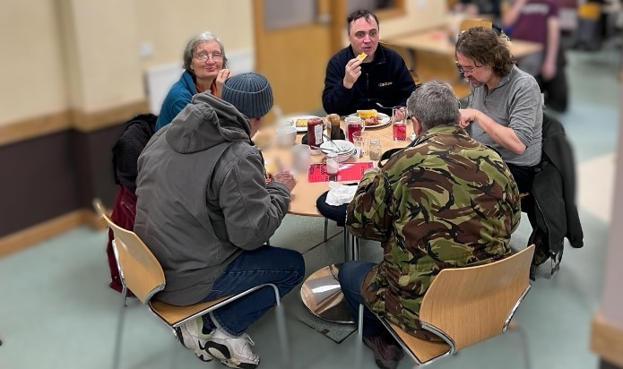

Malcolm *“I read about Big Breakfast Plus online and came here for something to eat and to get warm, especially in the winter. I had no idea what I was walking into, and I didn’t know anyone and was very quiet to start with. I would just come in, eat and leave. Then one day I started chatting to Chris and now we sit together. Originally, I came for the food but now it’s for the food and the company.”*

Wendy: “*I come in most days just come for the company. It’s lovely to know there is always someone to talk to and I like catching up with everyone’s news. And they do make a lovely cup of tea. I use my food vouchers getting tins of beans to give to Big Breakfast Plus.*

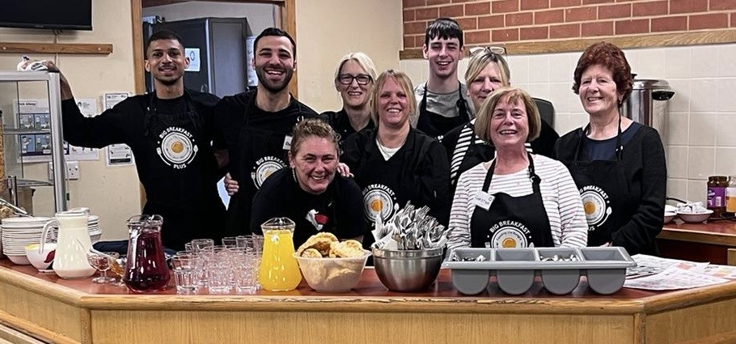

*We’re really privileged to be part of a wonderful group of dedicated and passionate volunteers at Big Breakfast Plus. Waking up early and being ready to serve breakfast to an average of 80 guests from 07:30 in the morning isn’t everyone’s cup of tea, but we see our volunteers rise to the task week in week out every week.”*

## **Staff and Personnel 2023 -24**

#### **Trustees**

Charlotte Mannion appointed Chair in August 2021

Nicky Walsh appointed Vice-Chair in November 2021

Sarah Smith December 2020

Clegg Bamber MBE December 2021

James Puttick August 2022

Frankie Walklate joined October 2023

Lisa Woodruff joined November 2023

Benedict Van der Linde resigned October 2023

Toby Boutle resigned October 2023

#### **Professional support**

Melodie Beevers - Treasurer

Shelia Bryant – Allford Bryant -Independent Examiner

#### **Staff:**

Suzy Gasiorek part time Cook retired 2 February 2023

Wayne Twitchell promoted to Services Coordinator 23 March 2023

Becky Middleton joined us as a part time Cook 4 sessions a week from 12 October 2023

Clair joined us as a Cook for three sessions a week from 7 February 2024

Sophie Boyce joined as a part time Administrator (6 hours a week) from 5 February 2024